Ref nr | Component | Change proposed. | Why? | Picture | Comments
8 | Roof | Canopies over front doors to be Glass Reinforced Plastic | Durability: resistant to weather, rot, and corrosion, making it a long-lasting and low-maintenance.  Lightweight: This makes them easy to install and handle.  Easy to install: often pre-fabricated and designed for straightforward installation.  Cost-effective: They can be a more affordable alternative to traditional porch construction. | 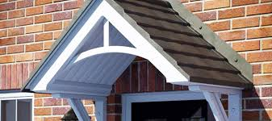
8 | Roof void | Locked roof access hatches | Improves security within communal loft-spaces
12 | External doors | Collapsible letter cages to be fitted to inside of door. | Keeps mail tidy and off the floor, preventing damage and making mail retrieval easier | 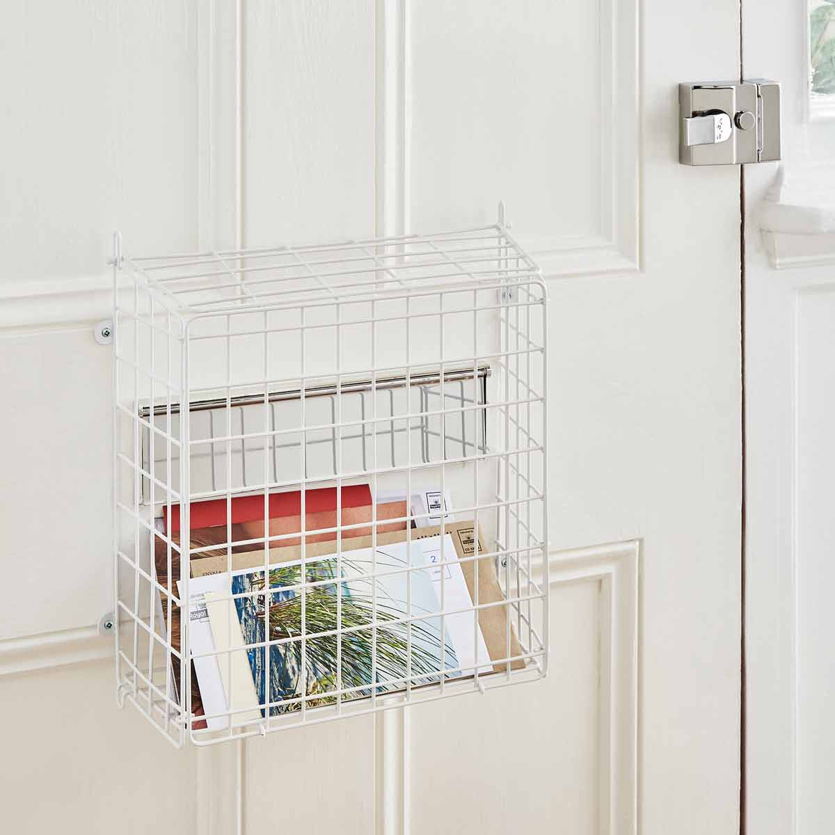
16 | Wall tiling | Bathroom wall tiling omitted in favour of high quality impervious panelling. | Waterproof, low-maintenance, and hygienic solution for walls, eliminating grout and reducing mould, while also being easy to clean and install | 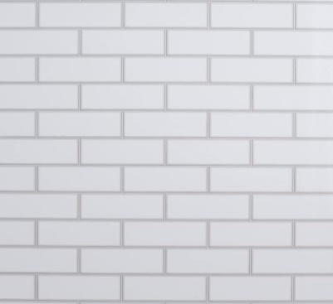
18 | Floor finishes | Provide wider choice of slip-resistant vinyl ranges to kitchen and bathroom floors. | To give tenants more choice on floor finishes
19 | Kitchen fittings | Worktop joints to be butt-jointed using jointing strips, connecting two pieces using bolts and sealant for a strong, smooth, and visually minimal join | To allow for easier replacement of damaged areas. | 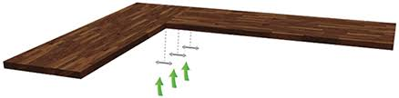  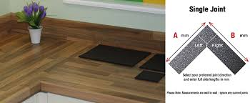
19 | Kitchen fittings | Approved suppliers to be confirmed – Howdens Greenwich White or Richmond range. | To help with standardisation and future maintenance
19 | Kitchen fittings | All drawers and cupboards to have soft-close hinges. | To reduce noise, increase longevity of cabinets and drawers, enhanced safety, and a enhance a premium feel
19 | Kitchen fittings | All drawers and cupboards to have chrome handles with no sharp edges. | To help with standardisation, future maintenance and safety
19 | Kitchen fittings | One kitchen wall cupboards to be lockable. | To prevent access to potentially dangerous items like cleaning products, medications, or sharp objects
19 | Kitchen fittings | Omit recycling containers from one base cupboard. | Why?
20 | Sanitary fittings | Over bath dryers for flats without gardens | To address the challenges of indoor drying, reduce damp and mould issues | 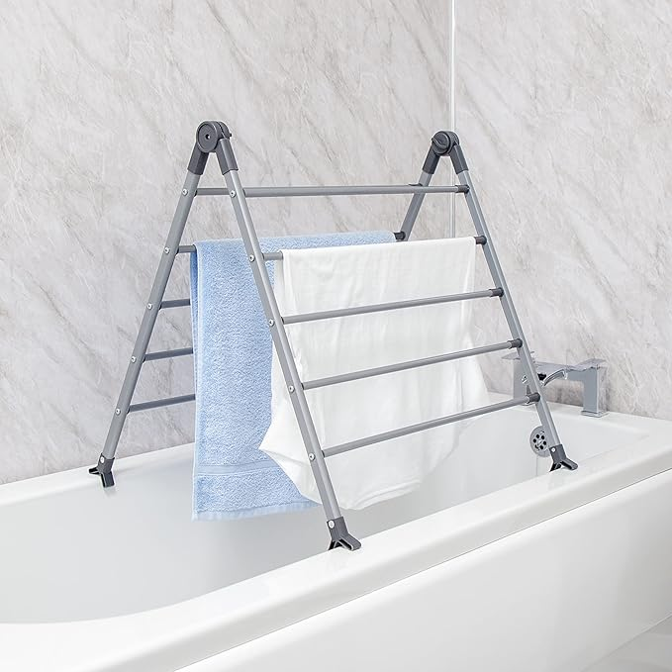 | Further discussion needed.
20 | Sanitary fittings | Where electric showers are specified, make shall be Mira – Sport or Advance 7.5kw. | To help with standardisation and future maintenance | 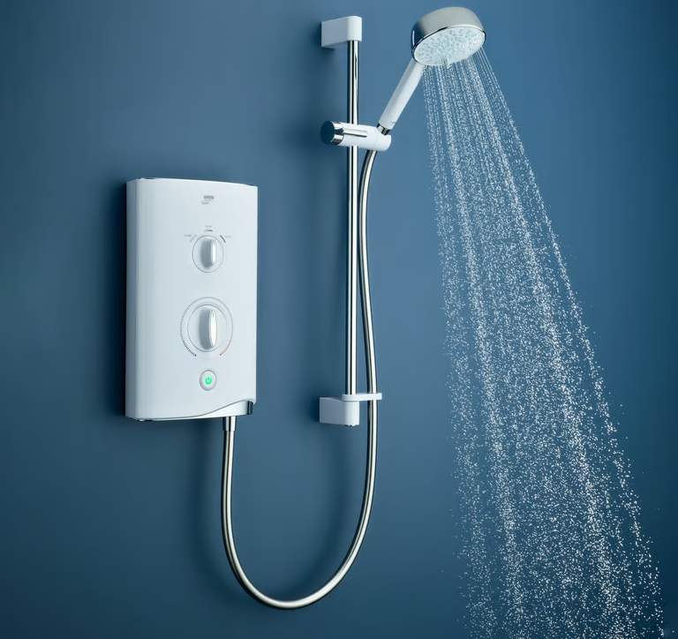
20 | Sanitary fittings | Omit toilet roll holder, shaver point, bathroom mirror and towel rail. | To help with standardisation and future maintenance |  | Heated towel can be fitted in lieu of bathroom radiator.
21 | Heating and plumbing | Broxtowe’s preferred source of heating remains Air Source Heat Pump, (ASHP) with Photovoltaic (PV) panels.  PV to be integrated into roof fabric not sit on top of roof tiles. | To help meet local and national decarbonisation requirements  a more streamlined and aesthetically pleasing design, potential cost savings on roofing materials, and increased wind resistance, while also maximizing roof space and reducing the need for additional mounting structures | 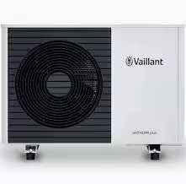  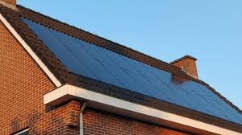 | Preferred ASHP manufacturer changed to Vaillant as this unit passes noise tests required by Planning
21 | Heating and plumbing | Omit garden tap. | To help with standardisation and future maintenance
25 | Electrical systems | A BT terminal for internet and telephone connection shall be provided, located adjacent to TV aerial point. | To ensure basic communication services are available to residents | 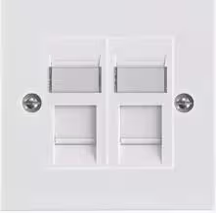
25 | Electrical systems | TV points shall be provided to the lounge, with digitally compatible cabling running to a junction box in the loft space. | To enhance tenant comfort and potentially encourage social interaction, as well as to ensure a basic level of functionality in the living space. | 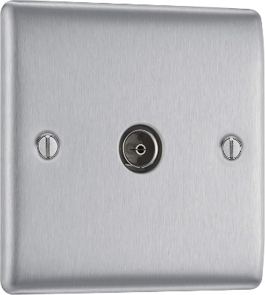
31 | Non-adopted drives and Parking Areas. | Tarmac preferred to block paving. Demarcation by means of thermoplastic white paint. | To help with standardisation and future maintenance | 