

SEX ESTABLISHMENTS

PROCEDURES AND CONDITIONS
(Approved 11 January 2011)

CONTENTS
SECTION |  | PAGE No.
1. | INTRODUCTION AND DEFINITIONS | 3
2. | BACKGROUND | 5
3. | MAKING AN APPLICATION | 7
4. | DETERMINATION OF APPLICATIONS | 9
5. | HEARINGS | 12
6. | APPEALS | 13
7. | ENFORCEMENT | 14
8. | MONITORING AND REVIEW | 14
9. | EQUALITY AND DIVERSITY | 15
APPENDIX
1. | SEVs AND THE TRANSITIONARY PROVISIONS | 16
2. | STANDARD CONDITIONS | 22
3. | HEARING PROCEDURES | 30

1. INTRODUCTION AND DEFINITIONS

1.1 The Borough of Broxtowe lies to the west of the City of Nottingham and is bounded by the River Trent to the south and the River Erewash to the west. There are four main towns (Beeston, Stapleford, Kimberley and Eastwood) each with its own character and individuality. There is a wide choice of employment, housing amenities and countryside which makes Broxtowe a very pleasant place to live and work. Nearly two thirds of the land in Broxtowe is open countryside with a number of areas noted for their particular charm and preserved as conservation areas. Industry offers employment ranging from large national companies such as Boots and the Royal Mail to a substantial number of industrial and commercial businesses across a wide range of services.

1.2 Definitions
In this Policy the following phrases bear the following meanings:-

The Act
The Local Government (Miscellaneous Provisions) Act 1982 (as amended).

The Council
Broxtowe Borough Council

Display of nudity
This means:
- in the case of a woman: exposure of her nipples, pubic area, genitals or anus; and
- in the case of a man: exposure of his pubic area, genitals or anus.

The Licensed Premises
The premises, vessel, vehicle or stall licensed by the Council as a Sex Establishment.

The Licensing Act
The Licensing Act 2003

The Licensing Officer
The Council’s Licensing Officer located at :
Broxtowe Borough Council
Licensing Department
Council Offices
Foster Avenue
Beeston
Nottingham
NG9 1AB
0115 917 3241

The Organiser
Any person who is responsible for the organisation or management of the relevant Entertainment or the Licensed Premises.

Permitted Hours
These are the hours of activity and operation that have been authorised under a Sex Establishment Licence.

The Policy
This document.

Relevant Entertainment
Εντερταινμεντ ασ δεφινεδ βψ Παρα 2Α οφ Σχηεδυλε 3 οφ τηε Αχτ

Relevant Locality
This is the locality where premises are situated or where the vehicle, vessel or stall is going to be used. The locality and the area that this covers is a matter for the Council to decide and will be determined on a case by case basis for the purpose of decision making.

Sex Article
A sex article as defined by paragraph 4, schedule 3 of the Act.

Sex Cinema
A sex cinema as defined by paragraph 4, schedule 3 of the Act

Sex Establishment
A sex establishment as defined by paragraph 4, schedule 3 of the Act

Sex Shop
A sex shop as defined by paragraph 4, schedule 3 of the Act

Sexual Entertainment Venue (SEV)
A SEV as defined by paragraph 2A, schedule 3 of the Act

Transitional Order
The Policing and Crime Act 2009 (Commencement No 1 and Transitional Saving Provisions) (England) Order 2010

2. BACKGROUND

ORIGINS OF THE LEGISLATION

2.1 In 1982 the Local Government (Miscellaneous Provisions) Act introduced a discretionary licensing regime for Sex Shops and Sex Cinemas. These provisions were adopted by Broxtowe Borough Council on 14 February 1983. In addition, activities such as table dancing, lap dancing, pole dancing and all forms of entertainment, dancing, or displays that included nudity or sexual performances of any kind were prohibited under the Council’s standard conditions attached to public entertainment licences.

2.2 In 2005 the Licensing Act 2003 introduced a new licensing regime which amalgamated several pieces of old legislation under the heading of “Regulated Entertainment”. Entertainment of an adult nature such as lap dancing, pole dancing and striptease etc. fell under this heading. However, the power for the community to object to such applications was restricted as any objection needed to relate to the four specified licensing objectives. This made it difficult for local communities to have any control on the number and/or location of these types of venues.

2.3 In order to address these concerns the Policing and Crime Act 2009 introduced provisions creating a new category of Sex Establishment known as a Sexual Entertainment Venue (SEV) to enable local authorities to require venues such as lap dancing establishments to be licensed as Sex Establishments. These provisions are also discretionary but the Council adopted them with effect from 26 July 2010. Special transitionary provisions have effect for SEVs from 1 October 2010 to 1 October 2011 and these are outlined in appendix 1.

SEX ESTABLISHMENTS

2.4 The definitions contained within the Act are complex defining three types of sex establishments licensable by this Council:
- Sex Shop,
- Sex Cinema,
- SEV

  - In general
- A Sex Shop is any premises, vehicle, vessel or stall used to a significant degree for hiring, selling, exchanging, lending, displaying or demonstrating Sex Articles and/or other things intended for use in connection with, or for the purpose of stimulating, or encouraging sexual activity and/or acts of force or restraint associated with sexual activity. This includes adult films and magazines.
- A Sex Cinema is any premises, vehicle, vessel or stall used to a significant degree for the exhibition of moving pictures concerned primarily with the portrayal of or which stimulates or encourages sexual activity, acts of force or restraint associated with sexual activity, genital organs, or urinary or excretory functions (e.g. pornographic movies). However, dwelling houses and cinemas showing films covered by the Licensing Act (e.g. a film rated by British Board of Film Classification) are excluded from this definition.
- A SEV is any premises which allows the live display of nudity, or, any live performance, before a live audience directly or indirectly for the financial gain of the Organiser or entertainer. Such entertainment must be of a nature that can reasonably be assumed to be provided solely or principally for the purpose of sexually stimulating any member of the audience (verbally or otherwise). Nudity is not a necessary element of such a performance and an audience can comprise one person. The term SEV is therefore likely to cover lap dancing, pole dancing, table dancing, strip shows, peep shows, live sex shows and potentially Burlesque.

2.6 This Policy applies to all forms of Sex Establishments unless otherwise stated. Whilst the Act allows applicants to apply to the Council for the requirement for a licence to be waived, the presumption is that such applications will be refused. Waivers will only be granted where applicants can establish that exceptional circumstances exist making it unreasonable or inappropriate for the premises to be licensed as a Sex Establishment.
3 MAKING AN APPLICATION

3.1 All applications relating to sex establishments must:-
- be made on the Council’s prescribed form which is available from the licensing officer and
- where the application is for a new premises licence, be accompanied by a clearly legible layout plan. Further guidance is available from the Licensing Officer
- be accompanied by the relevant fee

3.2 Applicants must:
- Serve a copy of their application on the Police at the address stated in the application form
- Give public notice of the application in the form prescribed by the Council. A copy of this form is available from the licensing officer. Notice of the application must be given by publishing an advertisement in the Nottingham Evening Post circulating in Broxtowe not later than 7 days after the date of the application.
- Where the application relates to premises, display a copy of the notice for 21 days beginning with the date of the application, on or near the premises and in a place where the notice can be conveniently read by the public.
- Provide a copy of the notice, the relevant page of the newspaper containing the advertisement, and a certificate confirming that the application has been publicised and served in compliance with the legislation to the Licensing Officer

3.3 Any failure to comply with the requirements of paragraphs 3.1 and 3.2 above may result in the application being deemed invalid and being rejected.
3.4 Whilst applicants for variation are not legally obliged to advertise their applications and serve a copy on the police, it is the Council’s policy that they should comply with paragraph 3.2 above.
3.5 Once an application has been received, the Licensing Officer will consult other relevant officers of the Council, local councillors and other relevant partners and stakeholders so as to gather appropriate information to be placed in the report to the Committee regarding the character of the relevant locality, the use to which any premises in the vicinity are put, and as to the layout, character, and condition of the premises.
3.6 Any person wishing to object to an application must do so in writing within 28 days of the date of the application stating the general terms of the objection. Objections received after this date may only be considered at the discretion of the Council if it feels that they are relevant. In determining whether to exercise the discretion to take late representations into account, the Council will have regard to the following:
- How late the objection is
- Whether there is a good reason for the objection being late or whether the lateness was intentional
- Whether it introduces new grounds of objection or information or whether it merely repeats other objections which were made in time
- Whether consideration of the late objection would result in unfairness to the applicant or disrupt the committee’s procedures
In appropriate circumstances the Council may defer determination of an application to allow the applicant time to respond to any late objections.
3.7 Applicants will be given notice of any objections that are received though the names and addresses of objectors will not be disclosed unless the objector gives the Council permission to do so.
3.8 With the exception of uncontested transfer applications, all applications relating to Sex Establishments will be heard by a meeting of the Council’s Licensing and Appeals Committee and both applicants and objectors will be invited to attend. The hearing procedure is outlined in section 5 and appendix 3.

4. DETERMINATION OF APPLICATIONS

4.1 Each application will be determined on its own merits. However applications may only be refused on certain defined mandatory or discretionary grounds.

4.2 Mandatory grounds
The Council must refuse an application if:
- The applicant is under 18 years if age; or
- The applicant has been disqualified from holding a licence under schedule 3 paragraph (17)(3) of the Act following revocation of a previous licence; or
- The person applying is not a resident of the UK, or was not resident during the six month period preceding then date of the application; or
- Where a company is the applicant, it is not incorporated in the United Kingdom; or
- The applicant has been refused a licence for the same premises within the preceding 12 months unless the refusal has been reversed on appeal

4.3 Discretionary grounds
The Council may refuse an application for the grant or renewal of a licence if:
- The applicant is unsuitable to hold the licence by reason of conviction of an offence or for any other reason: or
- The business would be managed or carried on for the benefit of a person other than the applicant who would be refused the licence if they made the application themselves: or
- The number of sex establishments, or sex establishments of a particular type, in the relevant locality at the time the application is made is equal to or exceeds the number which the Council considers appropriate for that locality: or
- The grant or renewal of the licence would be inappropriate, having regard to:
(i) the character of the relevant locality, or
(ii) the use to which any premises in the vicinity are put, or
(ii) to the layout, character or condition of the premises to which the application applies.

The Council has a wide discretion with regard to variation applications and may refuse the application if it thinks fit. Transfer applications can only be refused if :

- The applicant is unsuitable to hold the licence by reason of conviction of an offence or for any other reason: or
- The business would be managed or carried on for the benefit of a person other than the applicant who would be refused the licence if they made the application themselves

4.4 Suitability of the Applicant
The applicant will be required to demonstrate that he/she is a suitable person to hold a licence. In determining suitability, the Council will normally take into account:
- πρevious knowledge and experience of the applicant;
- information relating to the operation of any existing/previous licence held by the applicant, including any licence held in any other local authority area;
- information about the applicant and their management of the premises received from objectors, council officers or the Police including any known criminal convictions or cautions the applicant, or officers of any corporate applicants may have;
- any other relevant information

The above factors are not an exhaustive list of considerations but are merely indicative of the types of factors which may be considered in dealing with an application. Similar considerations may also apply to persons whom it is alleged would benefit from the granting of the application but would be unsuitable to hold the licence themselves. In such cases the Council will also have regard to any evidence to show that the business would in fact be carried on for their benefit.

4.5 Character of the Relevant Locality and use of other premises in the vicinity
The Council will not grant or renew a licence for a Sex Establishment if, in the Council’s opinion, it would be inappropriate to do so with regard to the character of the Relevant Locality or if the appropriate number of Sex Establishments (or of a particular type of Sex Establishment) in that locality would be exceeded. Whilst not intended to be an exclusive list, the Council will have particular regard to the following matters:
- the proximity of residential premises, including any sheltered housing and accommodation for vulnerable people;
- the proximity of educational establishments;
- the proximity of places of worship;
- access routes to and from schools, play areas, nurseries, children’s centres or similar premises in proximity to the premises;
- the proximity to shopping centres;
- the proximity to community facilities/halls and public buildings such as swimming pools, leisure centres, public parks, youth centres/clubs, etc;
- any planned or proposed regeneration of the area;
- any relevant planning considerations such as whether the premises are in a Conservation Area or areas designated as primarily residential or prime retail frontage;
- any complaints or reports of nuisance, disturbance, crime and /or disorder caused by or associated with the premises
- the proximity of other Sex Establishments;

Many of these issues will also be relevant when considering the uses to which other premises within the vicinity are put.

4.6 Layout, Character and Condition
The Council will not grant or renew a licence for a Sex Establishment if, in the Council’s opinion, it would be inappropriate having regard to the layout, character and condition of the proposed Sex Establishment. Whilst not intended to be an exclusive list, the Council will have particular regard to the following:
- the type of activity to which the application relates;
- the days and hours of operation of the activity;
- the layout and condition of the premises with particular concern for public safety, health and safety and the prevention of crime and disorder

4.7 Disability Access
Applicants are reminded of their duties under the Equality Act 2010 and should provide such facilities so as to enable the admission of disabled people.

4.8 Any licence granted by the Council, shall be subject to the relevant standard conditions outlined in appendix 2 (unless the Council determines to the contrary) and to any special conditions which the Council imposes.

5. HEARINGS

5.1 With the exception of uncontested transfer applications, all applications relating to Sex Establishments will be heard by a meeting of the Council’s Licensing and Appeals Committee. It will be the general practice of the Council to invite the Police and/or others who have lodged objections to appear and be heard at any hearings in addition to the applicant. However, the Council has a discretion and can, as a result, decide not to invite the Police and/or other objectors to hearings. In deciding whether to exercise the discretion, the Council will consider the facts surrounding each particular application and will aim to act fairly at all times.

5.2 Officers will notify the applicant, police and objectors of the date and time of the hearing. These parties shall give notice to the Council stating:

  - whether they will attend the hearing; and
  - the names and addresses of any witnesses that they intend to call;
and
  - a time estimate for their representations to the committee.
5.3 An agenda will be circulated prior to the hearing. This will include a copy of the application, a copy of any representations made by the Police and a summary in general terms of any objections received. The identity of the objector/s will not be made known without their prior consent (although information as to the general vicinity in which the objector/s live may be included).

5.4 Whilst additional material in support of the application or representation may be taken into account at the hearing, such material should be provided to the Council as soon as possible and at least 5 working days before the hearing.

5.5 Where there has been a failure to adhere to paragraph 5.4 above, or where additional material is produced at the hearing, this will only be admitted at the discretion of the Committee. This will usually be allowed only in exceptional circumstances and if the late production does not prejudice any other party in being able to respond fully.

5.6 Late objections/representations will be dealt with in accordance with paragraph 3.6 above.

5.7 Where a party does not attend the hearing and is not represented, the Council may either adjourn the hearing or may continue with the hearing in the party’s absence. If the latter option is followed, the committee will still consider any application, representation or notice submitted by the absent party in so far as it is relevant.

5.8 The hearing will concentrate on matters which are relevant to one or more of the grounds upon which a licence may be refused under the schedule 3 of the Act. (See section 4 above.)

5.9 The hearing will be inquisitorial and not adversarial. The procedure outlined in Appendix 3 will normally be followed.

6 APPEALS

6.1 Appeals against decisions of the Council are generally made to the Magistrates’ Court and appeals against decisions of the Magistrates may be made to the Crown Court. However, not all decisions carry a right of appeal.

6.2 The only persons entitled to appeal are:

- An applicant for the grant, renewal, transfer of a licence whose application has been refused; or
- An applicant for the variation of the terms, conditions or restrictions of a licence whose application for variation has been refused; or
- A holder of a licence who is aggrieved by any terms, conditions or restriction on that licence; or
- A holder of a licence whose licence is revoked

However, even these persons do not have a right of appeal in every case.

  - There is no right of appeal for the following:
- Objectors
- An applicant who has been refused the grant/renewal or transfer of a licence on any one of the mandatory grounds unless he seeks to show that the ground for refusal does not apply to him
- An applicant who is refused a licence on the grounds:-
- That there are sufficient sex establishments in the locality, or
- That to grant the licence would be inappropriate having regard to the relevant locality, use to which premises in the vicinity are put, or the layout, character, or condition of the establishment
The only means of challenge available for such persons is by way of Judicial Review.

  - Any application for an appeal must be lodged within 21 days from the date that the applicant was notified in writing of the decision against which he is appealing. A fee will be payable and the relevant court will advise as to the amount.

7 ENFORCEMENT

7.1 All decisions, determinations, inspections and enforcement action taken by the Council will have regard to the relevant provisions of the Act and the enforcement policy of the Council, which is produced to the principles of the Enforcement Concordat and the Regulators Compliance Code.

8 MONITORING AND REVIEW OF THIS POLICY

8.1 This Policy will be reviewed as and when appropriate. In preparing any succeeding Policy, regard will be had to data and information collated over the operating period of the current policy.

9 EQUALITY AND DIVERSITY

  - Broxtowe Borough Council is committed to promoting equal opportunities, valuing diversity and tackling social exclusion. The Council will aim to provide opportunities that meet the diverse needs of different people and groups of people by ensuring that services and employment opportunities are accessible to all. Everyone will be treated fairly and with respect. Diverse needs will be understood and valued. The Council will aim to eradicate all forms of discrimination.

Further information on the Council’s policy can be viewed on the website at
www.broxtowe.gov.uk

9.2 Advice and guidance will be made available in English which is the most common language of customers and stakeholders. Guidance documents issued by the Licensing Service will include advice about translation and access to information about services, however, it is recognised that local communities will normally have access to alternative translation and advice services. The Council will also signpost customers to other providers of guidance and information relevant to the regime but are not responsible for the accuracy of such information.

CONTACT DETAILS & FURTHER INFORMATION AVAILABLE FROM:
WEBSITE: www.broxtowe.gov.uk
E:MAIL: licensing@broxtowe.gov.uk

APPENDIX 1
SEVs and the transitionary Provisions

Schedule 7 of the Policing and Crime Act 2009 amended Schedule 1 of the Licensing Act 2003 to ensure that premises do not also require a Premises Licence, Club Premises Certificate or Temporary Event Notice in order to provide Regulated Entertainment at premises where:

- A Sexual Entertainment Licence is required
- The requirement of a Sexual Entertainment Licence is waived
- A Sexual Entertainment Licence has been granted, even if the premises are operating within the frequency exemption

As a result, the premises will not necessarily be required to be authorised under the Licensing Act for live or recorded music (or the provision of entertainment facilities for such purposes) if such activities are only associated with the sexual entertainment taking place.

However, the premises will need to be authorised under the Licensing Act if the following take place:
- The selling of alcohol or late night refreshment or provision of other forms of entertainment
- The selling of sexual entertainment without a Sexual Entertainment Licence and within the frequency exemption

The provisions relating to SEVs came into effect on 1 October 2010. This is known as the First Appointed Day. The Transitionary Provisions Order directs that the Second Appointed Day shall be 6 months after this date (i.e. 1 April 2011) and the Third Appointed Day, 12 months ( i.e. 1 October 2011).

EXISTING OPERATORS

Any existing operators who, immediately before 1 October 2010, held a premises licence or club premises certificate under which it was lawful to provide Relevant Entertainment under the Licensing Act and who lawfully used the premises as an SEV under that licence (or were undertaking preparatory work to use the venue in that way) will be allowed to continue to provide relevant entertainment until 1 October 2011 or the determination of any application they have submitted before that time (including any appeal against the refusal to grant a licence), whichever is later.

“Preparatory work” refers to work carried out by an operator, such as a refurbishment or refit, in order that they can use the premises as a SEV in the future. The operator will have been granted an authorisation under the Licensing Act before 1 October 2010 but will not have used the premises as a SEV by that date.

NEW APPLICANTS

Applicants wishing to use premises as an SEV after 1 October 2010, but who do not already have an authorisation under the Licensing Act or do have such an authorisation but have not taken any steps towards operating as such, will not be able to operate as a SEV after 1 October 2010 until they have been granted a SEV licence. If they do so they will commit a criminal offence for each day that they operate, for which the maximum penalty is a fine of £20,000 for each offence.

APPLICATIONS RECEIVED ON OR BEFORE 1 APRIL 2011

Applicants may submit their application for a SEV from 1 October 2010 onwards. Applications made on or after 1 October 2010, but on or before 1 April 2011, must be considered together. This is to ensure that applicants have sufficient time to submit their application and that all applications received on or before 1 April 2011 are considered on their individual merit and not on a first come first served basis.

No applications shall be determined before 1 April 2011. After 1 April 2011 the Council shall decide which, if any, licences to grant. If a new applicant is granted a licence it will take effect immediately. However, if an existing operator is granted a licence, it will not take effect until 1 October 2011, up to which point they will be allowed to continue to operate under their existing Licensing Act licence.

APPLICATIONS RECEIVED AFTER 1 APRIL 2011

These applications shall be considered when they are made, but only once all applications made on or before that date have been determined (reference to determination here does not include references to determination of any appeal against the refusal of a licence).

Again, licences granted to new applicants shall take effect immediately and licences granted to existing operators shall take effect from 1 October 2011 or, if later, the date the application is determined.

OUTSTANDING APPLICATIONS

The Council should attempt where possible to determine outstanding applications made under the Licensing Act, which include an application for the provision of Relevant Entertainment, before 1 October 2010. Where it has not been possible to determine an application before 1 October 2010, the Council should advise the applicant that they will need to submit an application for a sex establishment licence if they wish to provide relevant entertainment. From 1 October 2010 onwards, applicants shall be dealt with as though they are new applicants.

EXISTING LICENCE CONDITIONS

Licences granted under the Licensing Act to existing operators will contain conditions that relate expressly and exclusively to the provision of Relevant Entertainment. In such cases, to avoid duplication, where conditions on a Licensing Act licence relate only to the provision of Relevant Entertainment, they shall be read as if they were deleted from 1 October 2011 onwards.

In cases where conditions on a Licensing Act licence are inconsistent with, and less onerous than, the conditions in the licence granted under the Act they shall be treated as though they have been deleted.

Where granting a Sex Establishment licence to an existing operator, who is subject to conditions on their existing Licensing Act permission that relate expressly to the provision of Relevant Entertainment, the Council may replicate the existing conditions on the new Sex Establishment licence if they believe that the existing conditions are sufficient. However, the Council could equally decide to impose new conditions consistent with schedule 3 if they believe that new or additional conditions are necessary.

The Transitional Order does not require redundant conditions to be physically removed from the Licensing Act 2003. However, operators and the Council may agree that this is desirable in order to clarify the operator’s legal obligations. Such changes can be made via the minor variations procedure under section 41A of the Licensing Act.

ANNEX A:TRANSITIONAL GUIDANCE FOR EXISTING OPERATORS
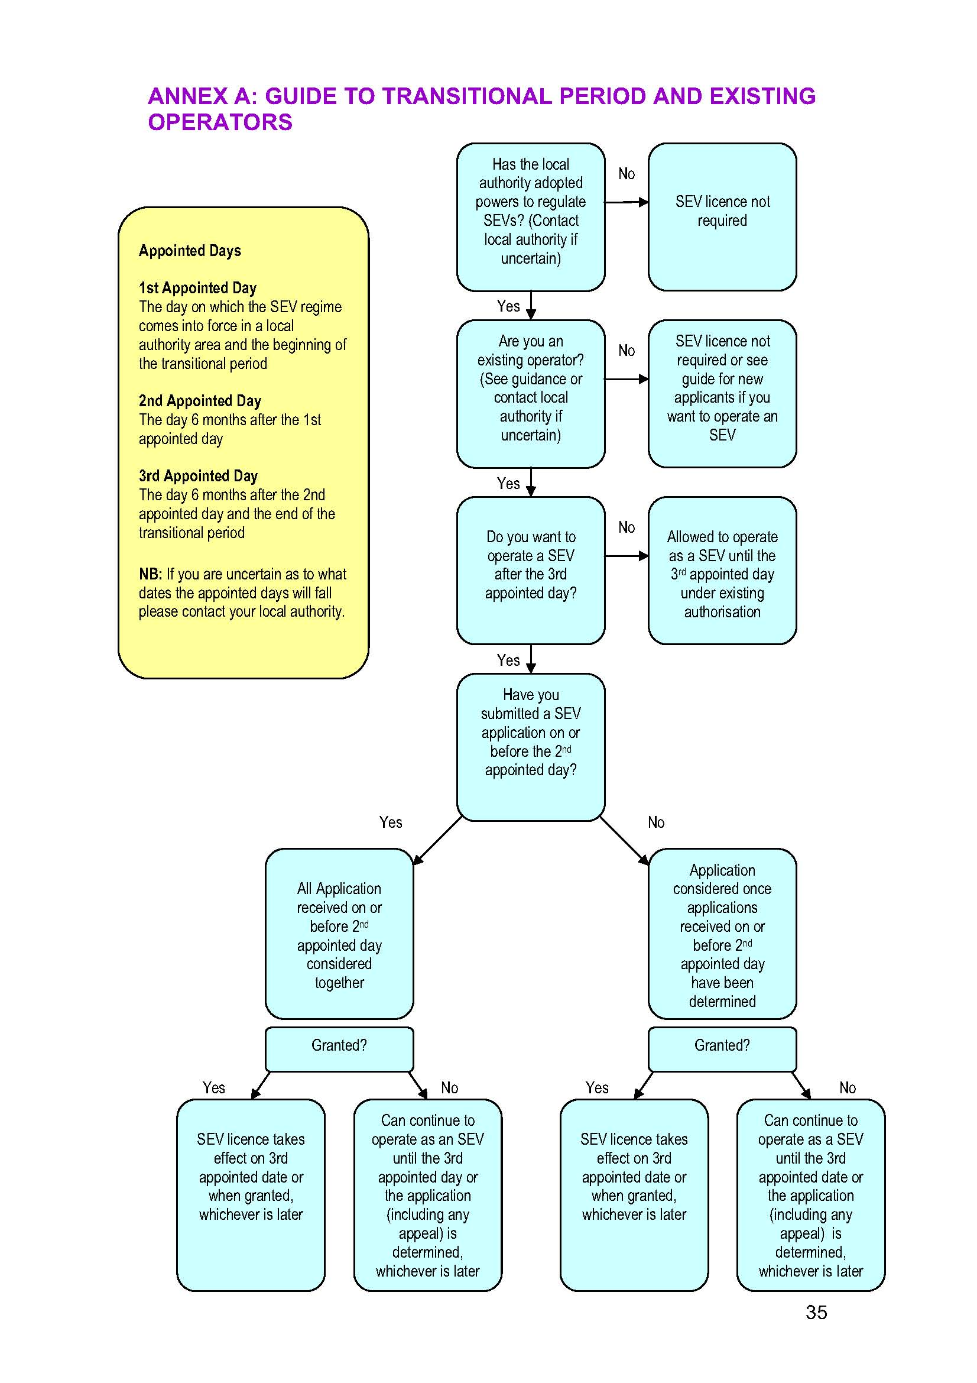

ANNEX B: TRANSITIONAL GUIDE FOR NEW OPERATORS
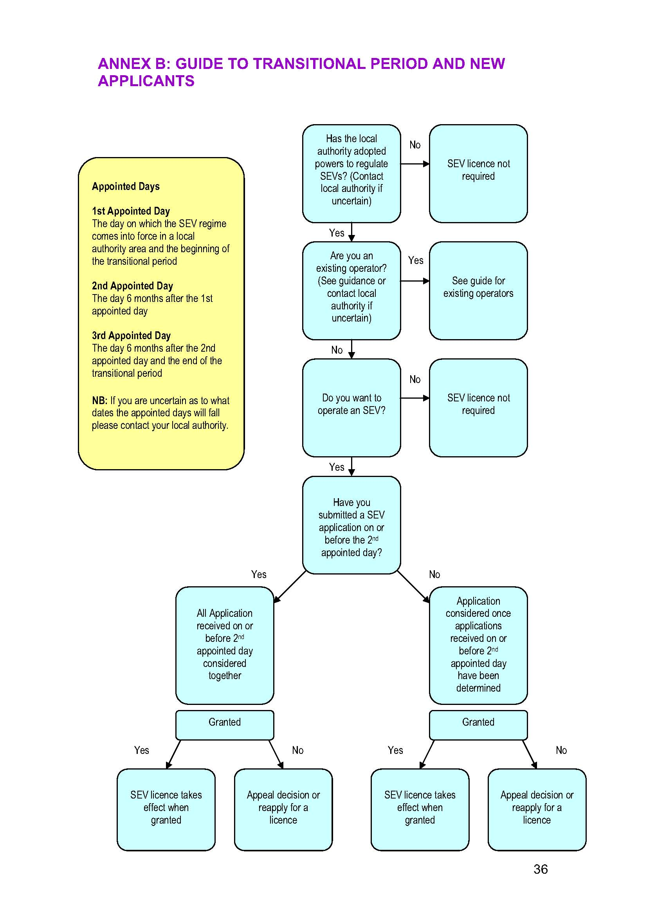

APPENDIX 2
STANDARD CONDITIONS

SEX SHOPS & SEX CINEMAS

1. The Premises shall be maintained in accordance with the lay out plan attached to this Licence. Amendments to the layout of the premises and/or any structural or physical alteration must be approved by way of an application for variation of this licence unless otherwise agreed in writing by the Council.
2 No-one shall be admitted to the premises who is, or appears to be, under the age of 18.
3 No person under the age of 18 shall be employed on the premises.
4. The Licensee or some responsible person nominated by him in writing for the purpose shall be in charge of and present on the premises while they are open to the public.
5. No change may be made from a Sex Shop to a Sex Cinema, or Sexual Entertainment Venue or vice versa.
6. A window display shall be maintained to the satisfaction of the Council in all windows of the Licensed Premises. Such display shall not include any Sex Articles or other indecent matter.
7. No Sex Articles shall be displayed within the premises as to be visible to passers by, whether the doors are open or closed.
8. For the purposes of these conditions:
- The Council means Broxtowe Borough Council
- Sex Article has the meaning assigned to it in paragraph 4 of schedule 3 of the Local Government (Miscellaneous Provisions) Act 1982.
- Sex Cinema has the meaning assigned to it in paragraph 3 of schedule 3 of the Local Government (Miscellaneous Provisions) Act 1982.
- Sex Shop has the meaning assigned to it in paragraph 4 of schedule 3 of the Local Government (Miscellaneous Provisions) Act 1982.
- Sexual Entertainment Venue has the meaning assigned to it in paragraph 2A of schedule 3 of the Local Government (Miscellaneous Provisions) Act 1982

SEXUAL ENTERTAINMENT VENUES

1. Risk Assessments

  - Risk assessments will be carried out and documented to the reasonable satisfaction of the Police and shall be lodged with them prior to this licence being used. The assessments shall cover the following areas:
- The prevention of crime and disorder
- safeguarding children;
- areas designated for the performance of dance and entertainment; and,
- levels of security at the premises
  - Any steps identified in such risk assessment. as being required to negate or lessen risks, are to be carried out by no later than 30 days from the date the Police indicates satisfaction with the said risk assessment, or such other date as the Police may agree.
  - The risk assessments are to be reviewed annually by the renewal date of this Licence. Copies of the reviewed documents shall be deposited with Nottinghamshire Police and shall clearly show the date of review, and any amendments made. All amendments must be agreed with the Police.
  - A risk assessment shall be conducted for all events involving outside promoters and this will be supplied to the Police 14 days prior to the event.

- Age

  - No person under the age of 21 years shall be allowed in the premises.
  - A Challenge 21 scheme shall operate at the premises. Any person who appears to be under 21 years of age shall not be allowed entry unless they produce an acceptable form of identification (passport, driving licence or PASS accredited card).

- Provision of Adult Entertainment

  - The Premises shall be maintained in accordance with the lay out plan attached to this Licence. Amendments to the layout of the premises and/or any structural or physical alteration must be approved by the Council by way of an application for variation of this licence unless otherwise agreed in writing by the Council.
  - No change may be made from a Sexual Entertainment Venue to a Sex Shop or Sex Cinema, or vice versa.
  - Admission to the premises shall be on payment of an admission fee.
  - Full nudity is not permitted. G-strings must be worn at all times and clothing shall not be transparent.
  - Performers shall not be less than 21 years old.
  - A record of the performer’s name, address, national insurance number, photograph and date of birth will be retained in a bound register. The details relating to national insurance number, name, address, date of birth; and proof of identity provided, to be checked and verified by the Licence Holder against other forms of identity. The performer’s details, as outlined above, shall be retained at the premises for at least 12 months and made immediately available to the Police and Authorised Officers of the Council upon request.
  - The entertainment provided at the venue will not be visible from the street.
  - Any person who can be observed from outside of the premises should be decently dressed and fully clothed.
  - The entertainment provided at the venue shall only be given by performers who are exclusively engaged for that purpose.
  - No performers shall be allowed to work at the premises if they are under the influence of intoxicating liquor or drugs.
  - There shall be no inappropriate contact or physical contact of a sexual nature between the performers and customers before, during, or after the performance. Customers may be led by the hand and escorted to an appropriate area for the dance and their hands may be placed on the seat or on their lap prior to the dance commencing. Payment may be made into the hand or a garter.
  - Risk assessments shall be carried out in relation to areas which are to be used for the performance of dance and entertainment in accordance with conditions 1.1 to 1.3.
  - Private dancing in secluded areas is prohibited. All dance areas shall be well lit.
  - The use of any types of marital aids, sex toys, animals or types of objects appearing to be such is expressly prohibited during the performance as is simulated sexual activity.
  - The entertainment provided shall be restricted to dancing and removal of clothes and there shall be no other form of sexual activity.
  - The Licence Holder and any other person concerned with the management or provision of entertainment at the premises shall not allow the audience to throw money or otherwise give gratuities to the performers, except as permitted by condition 3.11 above or 3.23 below.
  - Performers shall be provided with changing rooms that are located separately and apart from the public areas and facilities. Such changing rooms shall be fitted with security locks.
  - Only performers and staff authorised by the Licence Holder shall be permitted in to the changing rooms.
  - The contents of the House Rules for dance performances shall be agreed with the Police and the date indicated on those rules. A copy of the rules shall be deposited with the Police and the Council. These rules shall be adhered to and any amendments must be agreed to by the Police. In the event of any agreed amendments being made, an amended copy of the House Rules will be deposited with the Police and the Council with such document clearly showing the date of amendment.
  - Performers who are not performing shall not be in any public area in a state of undress (which includes the displaying of naked female breasts).
  - There shall be no advertising or display outside of the premises to the general public of photographs or other images displaying topless or nude dancers, or showing anything of a sexual nature.
  - A member of staff will be available to escort performers from the premises to their own/public transport or taxi at the end of their working day if requested to do so.
  - The Licence Holder will adhere to and enforce a “Customer Code of Conduct which will be clearly displayed for all customers to see and will include the following terms:
- There shall be no inappropriate touching of the dancers at any time. Customers may however be escorted by the hand to an appropriate area for a dance and may make payment in the dancer’s hand or garter.
- No verbal abuse will be tolerated. Any customer being abusive will be ejected from the premises.
- No irresponsible behaviour by customers will be allowed. Any customer engaging in such behaviour will be ejected from the premises.
- Any customer behaving in any other unacceptable manner will be asked to leave the premises.
- No customer shall accept from or give to any performer or member of staff any telephone number, business card or note.
3.21 The Licence Holder will adhere to and enforce a “Dancer’s Code of Conduct” which will be clearly displayed for all performers and staff to see and will include the following terms:
- Performers shall behave responsibly at all times and professionally perform appropriately choreographed dance routines.
- Performers will not remove any items of clothing otherwise than in accordance with the Sexual Entertainment Venue Licence. In particular full nudity is prohibited.
- No performer will accept from or give to a customer any telephone number, business card or note.
The Licence Holder shall ensure that all dancers/entertainers performing at the premises have signed a declaration to confirm that they are aware of, have understood and will abide by this Code. The Licence Holder shall retain this declaration until such time as the dancer/entertainer ceases to perform at the premises.

- Records

  - A record shall be kept of anyone refused admission to the premises or refused service. Details contained in this record shall show:
- the basis for the refusal;
- the person making the decision to refuse; and,
- the date and time of the refusal
This record shall be retained at the premises for at least one year from the date of refusal and shall be made available for inspection and copying by the Police and Authorised Officers of the Council immediately upon request.
  - A bound and sequentially paginated incident/accident book shall be kept to record all instances of disorder, damage to property and personal injury at the premises. This book shall be made available for inspection and copying by the Police and Authorised Officers of the Council immediately upon request and all such books shall be retained at the premises for at least 2 years from the date of the last entry.
  - When the toilets have been checked for drugs use and supply, in accordance with condition 6.5 below, a record shall be kept of the result of the checks detailing how and when any illegal substance was found. The record shall be retained at the premises for at least 3 months from the date of the check and shall be made available for inspection and copying by the Police immediately upon request.
4.4 Any seizures of drugs, weapons or other property shall be recorded, together with the name and address of the person found with the article and details of how and where the article was seized. This record shall be kept in a bound and sequentially paginated book, which shall be retained at the premises for at least 2 years from the date of the last entry. This record shall be made available for inspection and copying by the Police immediately upon request.
  - A bound and sequentially paginated book shall be kept and updated daily, containing the names, addresses, dates of birth, Security Industry Authority (SIA) registration number and hours worked of door supervisors employed on each day that the premises operate. This book shall be kept at the premises for at least 12 months from the date of the last entry and shall be made available for inspection and copying by the Police immediately upon request.
5. Notices
  - Notices will be displayed at the entrance to the premises advising customers that random searches will be carried out and admission will be refused to customers who do not give their consent to being searched.
  - A copy of the current House Rules will be displayed at the entrance to the premises so as to be clearly visible to customers as they gain admission.
  - The current Customers’ Code of Conduct, Dancers’ Code of conduct; and House Rules shall be displayed on the exterior and interior of the premises at all times so as to be clearly visible.
  - A copy of the current conditions attached to the Sexual Entertainment Venue Licence and House Rules shall be exhibited at all times in or near the performers’ changing rooms so that they can easily be read by performers. These documents shall be protected against theft and defacement.
5.5 A clear notice shall be displayed in a prominent position so that it can easily be read by persons entering the premises stating:
“No persons under 21 years of age permitted.”
6. Safety and Security

6.1 CCTV cameras shall be installed and maintained in the premises in accordance with Police recommendations and sufficient staff shall be trained to use the system. All cameras will record continuously during the time the premises are open to the public. Images shall be of evidential quality and shall be retained for at least 31 days. Recordings shall be made available immediately upon request to the Police and Authorised Officers of the Council.
6.2 At all times the premises are open to the public, all public areas shall be supervised by CCTV and all dance areas, private or otherwise, shall be constantly monitored by CCTV and staff.
  - The Licence Holder, or person nominated by him in writing to be in charge on any specified occasion, shall take all reasonable steps to ensure that patrons awaiting entry to the premises or leaving the premises do not cause annoyance or nuisance to any other person in the vicinity of the premises. A door supervisor shall act as a marshal to ensure that members of the public can freely pass by and gain access to other premises as necessary and shall supervise persons awaiting entry on the pavement.
  - Door staff will conduct random searches of customers prior to admission for drugs and weapons. Anyone refusing to be searched will be refused entry.
  - The toilets at the premises shall be checked for drugs use and evidence of drug supply taking place at least daily during the times that the premises are open to the public. Cocaine wipes shall be used when carrying out the checks. Records of such checks shall be kept in accordance with condition 4.3.
  - If drugs are found during a personal search, or whilst being used within the premises, the Licence Holder or Manager shall ensure, if safe and practicable, that a clear image of the person found in possession will be captured on CCTV. Following a risk assessment of the situation arising from the find, any person found using or in possession of drugs shall be detained, if it is safe and practicable to do so, and the Police shall be called immediately.
  - Any drugs or weapons found on the premises, either during a search of any person or otherwise, will be confiscated and stored in a secure container prior to being handed over to the Police, which must be done as soon as is practicable.
  - SIA registered door staff shall be employed at the premises, both inside and outside, at all times that the premises are open to the public. The number of door staff required shall be agreed with the Police. Appropriately trained staff shall supervise the admissions desk and all dance and entertainment areas at all times.
  - The Licence Holder, or person nominated by him in writing to be in charge on any specified occasion, will conduct a risk assessment to ensure that adequate levels of security are maintained, in accordance with conditions 1.1 to 1.3. Security at the front door of the premises shall not be compromised by the need for supervisors at locations within the premises.
  - The Licence Holder or person nominated by him in writing to be in charge on any specified occasion shall ensure that any door staff employed at the premises wear and clearly display their SIA registration badge at all times whilst on duty.
  - The Licence Holder and their staff shall liaise and co-operate closely with Nottinghamshire Police in respect of any initiative in relation to drugs, weapons or like matters.

7. Policies
  - The Licence Holder shall devise and agree the following policies with the Police prior to this licence being used:
- a Dispersal Policy,
- an Accident and Incident Policy
- a Drugs Policy
- an Admission Control Door Supervision Policy
- an Age Admission Policy
The date that each policy is agreed with the Police shall be indicated on the policy and copies will be lodged with the Police and the Council. The terms of each policy will be adhered to with any amendments being agreed to by the Police. In the event of any agreed amendments being made, an amended copy will be deposited with the Police and the Council, such document clearly showing the date of amendment.
7.2 The Licence Holder shall ensure that all relevant staff (including SIA door staff) working at the premises have signed a declaration to confirm that they are aware of, have understood, and will abide by these policies. The Licence Holder shall retain each declaration until such time as the staff member ceases to work at the premises

APPENDIX 3
HEARINGS PROCEDURE

- The following procedure will ordinarily be followed at the committee hearing:

- The Chair will introduce him/herself, the other members and officers attending. The applicant, then the Police and objector/s (if invited and present) will introduce themselves and their witnesses. The Chair will outline the procedure to be followed and explain any time limits imposed on representations.

- The applicant will present his case and ask his witnesses to give their evidence. The applicant and each witness, after giving their evidence, may at the discretion of the Chair, be asked questions by the Police, the objector/s, the Committee members and the legal adviser.

- The Police and objector/s (if invited and present), in turn, will then be asked to make their representations following which they will be asked questions by the applicant, the committee and legal adviser.

- Once all parties have given their evidence and all questions have been asked, each party will be asked to sum up their case. The order of summing up will be the Police and the objector/s (if present) with the applicant last.

- Hearings will normally be conducted in public, however the Committee does have powers of exclusion (which cover the public, the press, and even applicants, objectors and their representatives) in appropriate circumstances.

- Whilst it will only hear representations which are relevant, the Committee is not restricted to considering any objections raised. In coming to a decision it will consider all relevant information, including observations by Council Officers, the Police and objectors (whether or not these parties are invited to speak at the hearing), representations by the parties at the hearing, as well as the local knowledge of the members of the committee.

- Due to time constraints, applications for adjournments will only be granted when absolutely necessary, taking into account the following:

- Once a hearing date has been set it is for the parties to ensure that they can attend or are represented. Hearings may proceed in the absence of a party and their representations will be taken into account.

- If it is not possible for a party or their witnesses to attend the hearing, then the Council’s preference will be for the hearing to proceed and the representation to be given by way of written evidence.

- Any party who wishes to make an application for an adjournment should seek the consent of all other parties to the application and notify the Council as soon as possible that an adjournment is being sought. If all parties agree the matter may be adjourned administratively.

- If an adjournment is not agreed administratively prior to the hearing, then the matter will remain listed, the application for the adjournment will be heard and the committee will decide whether to allow the adjournment or to proceed on written evidence.

- The Council may adjourn proceedings of its own motion where it considers it necessary for consideration of any application or objection.

- Where an adjournment is granted, all parties will be notified soon as possible and notified of the new hearing date.

- In coming to a decision the committee will have regard to any rights the applicant may have under the European Convention on Human Rights, Article 10 (right of freedom of expression) and Article 1 Protocol 1 (protection of property), as qualified, and will weigh them in the balance.

- At the end of the hearing the committee will retire to make their decision. In all cases the Committee will try to make their decision and to communicate this, with reasons, within a reasonable time of retiring. Where this is not possible the committee may:
- announce their decision on the day with reasons to follow; or
- delay their decision and reasons for a set period.

- However the decision is delivered, it will always be followed up with written notification of the decision to all parties, including full reasons and information where relevant, about the appeals process.

Belfast City Council v Miss Behavin’ Ltd Northern Ireland [2007] UKHL 19 [2007] LLR 312

