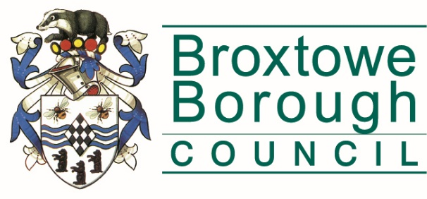
Broxtowe Borough Council
Licensing
Council Offices, Foster Avenue,
Beeston, Nottingham, NG9 1AB
Phone: 0115 917 3241
Fax: 0115 917 3683
Email: licensing@broxtowe.gov.uk

Disclosure of convictions and civil immigration penalties and declaration

Before completing this form please read the guidance notes at the end of the form.
If you are completing this form by hand please write legibly in block capitals. In all cases ensure that your answers are inside the boxes and written or typed in black ink. Use additional sheets if necessary.

You may wish to keep a copy of the completed form for your records.

1. Your personal details
TITLE Please tick 
Mr Mrs Miss Ms Other (please state)
Surname
Forenames
PREVIOUS NAMES (if relevant) please enter details of any previous names or maiden names. Please continue on a separate sheet if necessary.
TITLE Please tick
Mr Mrs Miss Ms Other (please state)
Surname
Forenames

2. Forfeiture by a court or revocation by a licensing authority of a personal licence in the last 5 years
Has any personal licence held by you been forfeited or revoked in the last 5 years?
Please tick
Yes No
If yes, please provide details below:
Data | Information
Name of court/licensing authority
Address of court
Date of forfeiture/revocation
Offence which resulted in the forfeiture/revocation
Any additional details

3. Relevant or foreign offences and civil immigration penalties
Read Note 1
Have you been convicted of any relevant offence or foreign offence or been required to pay a civil immigration penalty?
Please tick
Yes No
If you have been convicted of any relevant offence you must provide details for each conviction of the date of conviction, the name and location of the convicting court, offence of which you were convicted and the sentence imposed:

If you have been convicted of any foreign offence you must provide details for each conviction of the date of conviction, the name and location of the convicting court, offence of which you were convicted and the sentence imposed:

If you have been convicted of any foreign offence you must provide details for each conviction of the date of conviction, the name and location of the convicting court, offence of which you were convicted and the sentence imposed:

4. Declaration
I declare that I have not been convicted of any relevant offence or any foreign offence or been required to pay a civil immigration penalty
SIGNATURE

DATE

5. Declaration
The information contained in this form is correct to the best of my knowledge and belief.

It is an offence knowingly or recklessly to make a false statement in or in connection with an application for the grant or renewal of a personal licence. A person is to be treated as making a false statement if he produces, furnishes, signs or otherwise makes use of a document that contains a false statement. To do so could result in prosecution and a fine of any amount. It is an offence under section 24B of the Immigration Act 1971 to work illegally.

SIGNATURE

DATE

NOTES

- Relevant or foreign offences

Relevant offences are the offences listed in Schedule 4 to the Licensing Act 2003:

The meaning of foreign offence is dealt with in section 113 of the Licensing Act 2003.

If you are the holder of a justices’ licence and you are applying for a personal licence under regulation 8 of the Licensing Act (Personal licences) Regulations 2005 see paragraphs 23 and 28 in Part 3 of Schedule 8 to the Licensing Act 2003 for the information you are required to give.

If you are convicted of any relevant or foreign offence during the period between when your application is made and when your application is determined or withdrawn, you must notify the authority to which your application was made. Failure to do so without reasonable excuse could lead to prosecution and a fine not exceeding level 4 on the standard scale.

Civil immigration penalty

An Immigration penalty means a penalty under either section 15 of the Immigration, Asylum and Nationality Act 2006 or section 23 of the Immigration Act 2014.

