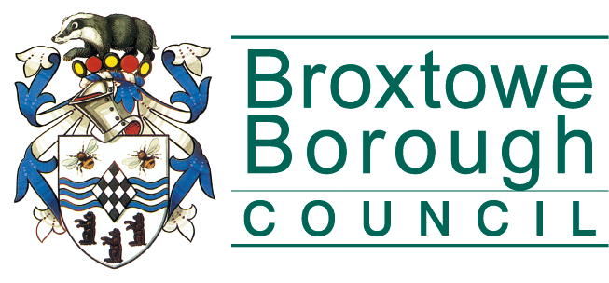 | Broxtowe Borough Council  Licensing Department  Council Offices, Foster Avenue,  Beeston, Nottingham NG9 1AB  Tel: 0115 917 3241  Fax: 0115 917 3131  Email: licensing@broxtowe.gov.uk

Licensing Act 2003 Guidance Fact sheet
Temporary Event Notices

Permitted Temporary Activities
If you’re organising a temporary event and want to serve or sell alcohol, provide late night refreshment, or put on regulated entertainment, you’ll need to complete a temporary event notice (TEN).
A TEN is a form that you provide to the local council, the police and environmental health, letting them know about the planned event. A TEN can be given in respect of both indoor and outdoor events. "Premises" for the purposes of the Act means any place, whether indoors or outdoors.
There are two types of TEN:
- a standard TEN, which is given no later than 10 working days before the event to which it relates
- a late TEN, which is given not before 9 and not later than 5 working days before the event.

What qualifies for a TEN?
- fewer than 500 people attending.
- the event must last no more than 168 hours and can be held either outdoors or indoors.
- any premises can only be used for 15 temporary events per year, up to a total maximum of 21 days.
- you must be over 18 in order to hold a temporary event.
If you have a personal licence, you can give 50 TENs (made up of standard and late TENs) a year; if you don’t have a personal licence you can only give 5 (made up of standard and late TENs).
If you have a personal licence, you can give 10 late TENs a year; if you don’t have a personal licence you can only give 2 late TENs.
There must be at least 24 hours between temporary events organised by the same person.
Once the Police or Environmental Health receive your TEN, they have three working days to make any objections to it on the grounds of any of the four licensing objectives: prevention of crime and disorder; prevention of public nuisance; public safety; protection of children from harm. If there are no objections, the event will go ahead as planned. If they object, the council will organise a hearing to consider the evidence and may impose conditions or decide that your event cannot proceed.
Please Note: If there is an objection to a late TEN the event will not be allowed to proceed.
How do I give a TEN?

You must give a notice, at least 10 working days prior to the day on which the event period begins, to the relevant Licensing Authority together with the fee of £21. You must also send a copy of the notice to the relevant Chief Officer of Police and Environmental Health Department (again at least 10 working days prior to the day on which the event period begins).
The notice must contain a statement of:
- the licensable activities that will take place
- the period during which it is proposed to use the premises for those activities
- the times during the event period when licensable activities are to take place
- the maximum number of persons to be allowed on the premises at any one time (not exceeding 499)
- if the supply of alcohol is involved, whether the supplies will be for consumption on or off the premises or both
- where the licensable activities include the supply of alcohol, the condition that all such supplies are made by or under the authority of the premises user
- any other matters prescribed by the Secretary of State in regulations prescribed in the form of the temporary event notice.

What is the procedure once a TEN has been given?

If the TEN is within the permitted limits of permitted temporary activities the Licensing Authority must issue acknowledgement of the TEN. There is no requirement for the Police or Environmental Health to acknowledge the notice as well.

If the temporary event notice exceeds the permitted limits the Licensing Authority must give the premises user a counter notice, copied to the Police and Environmental Health, preventing the event from taking place.

Will I be able to give a TEN if my premises can hold more than 499 people?
Yes, as long as you ensure that the number of people on the premises during the event period authorised by the TEN does not exceed 499 at any one time. If you think that more than 499 people will attend the event you will need to apply for a premises licence to cover the event. Otherwise, if this limit is exceeded, the event will be unauthorised and the premises user liable to prosecution.

Are there any extra restrictions when a temporary event notice includes the supply of alcohol?
Where the relevant licensable activities include the supply of alcohol, the notice must make it a condition of using the premises for such supplies, that all such supplies are made by or under the authority of the premises user (i.e. the person who applied for the TEN).

Does the premises user have to display the TEN at the event?
The premises user must either
- secure that a copy of the TEN is prominently displayed at the premises being used for the permitted temporary activity
- secure that the TEN is kept at the premises in his custody
- secure that the TEN is kept at the premises in the custody of a person who is present and working at the premises and whom he has nominated for this purpose (and if this is the case, secure that a notice specifying this fact and the position held at the premises by that person is prominently displayed at the premises)
What happens if a premises user loses the TEN?
Where a TEN is lost, stolen, damaged or destroyed, the premises user may apply to the Licensing Authority for a copy of the notice. No application may be made more than a month after the end of the event period specified in the notice. Any application must be accompanied by the prescribed fee.
For further information please contact the Licensing Department

Broxtowe Borough Council  Licensing Department  Council Offices  Foster Avenue  Beeston  Nottingham  NG9 1AB  Phone: 0115 917 3241  Fax: 0115 917 3131  Email licensing@broxtowe.gov.uk  Internet: www.broxtowe.gov.uk | The Chief Constable  Nottinghamshire Police  County Division Licensing Team  Mansfield Police Station  Great Central Road  Mansfield  Nottinghamshire  NG18 2HQ  Telephone 101 ext. 805 3377  Email  liquor.licensing@nottinghamshire.pnn.police.uk | Broxtowe Borough Council  Environmental Health  Council Offices  Foster Avenue  Beeston  Nottingham  NG9 1AB  Phone: 0115 917 3485  Fax: 0115 917 3131  Email  health@broxtowe.gov.uk  Internet: www.broxtowe.gov.uk

