Housing’s Garden Competition 2026
Entry Form

Name)……………………………………………………………………….
Address) ……………………………………………………………………
Email Address) …………………………………………………………….
Contact Number) …………………………………………………………..

Categories
- House Garden
- Flat Garden
- Independent Living Communal Garden
- Eco Garden
- Pots/Hanging Baskets
The judging criteria will focus on colour, variety, sustainability, creativity and effort.

Prizes
Winner and runner up for each category can choose between garden vouchers or Afternoon Tea at Trowell Garden Centre.
Winner - £50 Voucher or Afternoon Tea for 2
Runner up - £25 Voucher or Afternoon Tea for 1
Additionally, one 1st place winner can opt instead for a private visit to one of the gardens from the Beeston and Chilwell Garden trail plus tea and cakes!
Judging
Judging will take place on a weekday between Monday 22 June – Friday 3 July. Please indicate your preference and availability below. You will be informed of the exact date closer to the time.

____________________________________________________________

The Council may use photographs of garden competition entries in future publicity and publications on the website and in the newsletter.

You must be a current Broxtowe Borough Council Tenant or Leaseholder to enter.
Proudly sponsored by

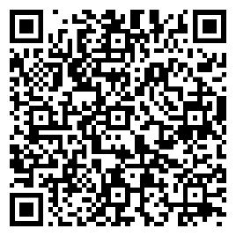
If you need any assistance to complete this entry form or if you have any questions about the competition, please contact the Engagement Team on 0115 917 3935 or email housingengagement@broxtowe.gov.uk

Please send completed entry forms to Housing Engagement Team, Broxtowe Borough Council Offices, Foster Avenue, Beeston, NG9 1AB.
Privacy Notice
All information collected will be used by Broxtowe Borough Council for the intended purpose(s) only. Your personal details will not be shared with other organisations unless otherwise stated or the Council is legally required to do so.

You may contact the Council if you wish to stop us using your personal data for these purposes.
For more information, please view our privacy notice on the QR code:

